Room 5 Question 1
Advanced Breast Cancer (Reviewed by Dr. Chambers)
Stem: A 42-year-old female presented with a self-detected breast mass for further investigation and discussion of treatment options. Approximately 1 month ago, she discovered an ill-defined, large mass in her right breast while bathing. She denies any symptoms related to the breast including breast pain, nipple discharge, or changes to the overlying skin.
PMH: Denies
Family history: Unremarkable.
Meds: None
Social history: Nondrinker and nonsmoker.
Physical examination:
- Right breast mass measuring approximately 6 cm in size is located in the upper central and upper inner quadrant.
- No overlying skin changes.
- No supra- or infraclavicular adenopathy
- Palpation of the right axilla is remarkable for adenopathy. The nodes are firm but mobile and nontender.
- Examination of the left breast and axilla is unremarkable.
- Vital signs are normal.

What is your differential diagnosis?
- Invasive ductal carcinoma.
- Invasive lobular carcinoma.
- Breast abscess
- Breast lymphoma
- Phyllodes Tumor.
- Metastasis from another primary.
- Fibroadenomas
How are you going to evaluate this patient?
- Thorough History: Assess for risk factors.
- Bilateral mammograms: The patient’s workup confirms the presence of a right breast mass measuring 6.5 cm.
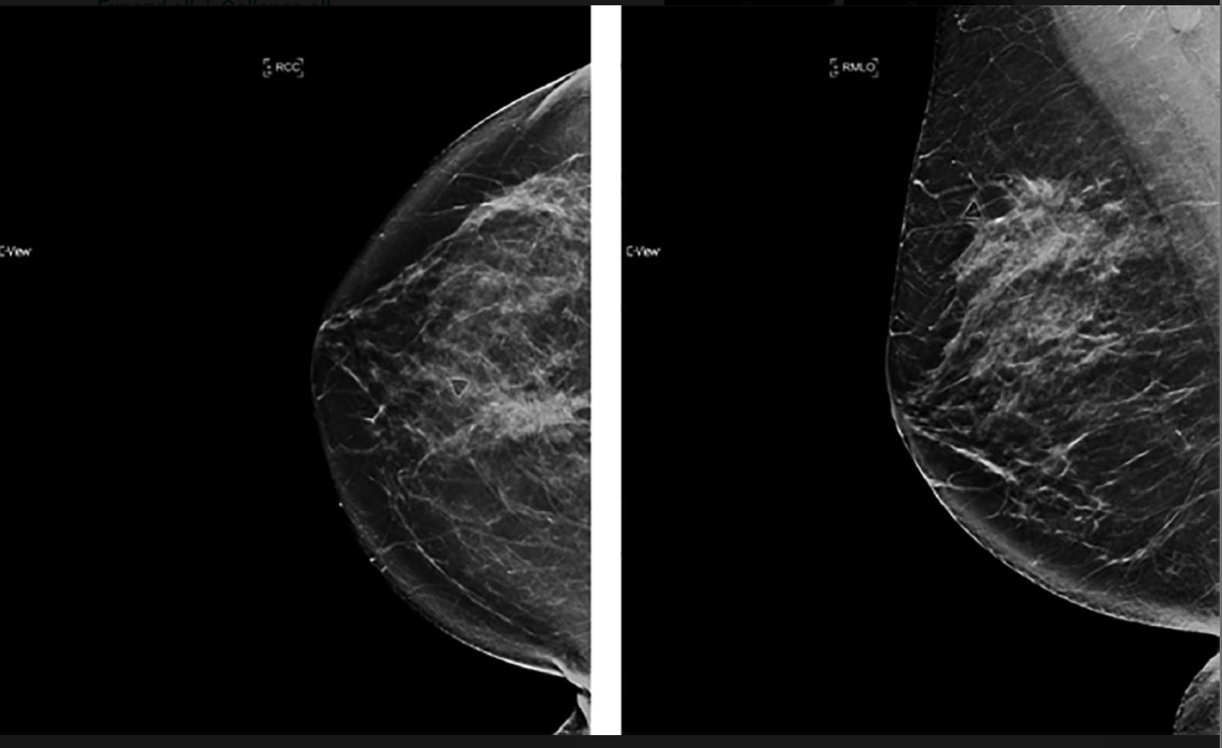
- Ultrasound of the mass and axilla : Ultrasound of the ipsilateral axilla demonstrates the presence of two large morphologically abnormal lymph nodes.

- Core biopsy: Invasive ductal carcinoma, grade III, ER negative, PR negative, and Her2 negative.

- FNA of the suspicious lymph nodes: Positive for metastatic disease.

- MRI can be considered
- Metastatic workup was negative for metastatic disease.
- No radiographic abnormalities were noted on the left breast or axilla.
What is your TNM stage for this patient?
- Clinical cT3N1, Stage IIIA, triple-negative breast cancer.
(The tumor is 6.5 cm in maximum diameter (T3). There is evidence of axillary lymph node involvement in the right axilla (N1), and there is no evidence of distant metastatic disease (M0). )
How would you manage this patient?
- Multidisciplinary discussion / Tumor boards.
- Genetic counseling ( premenopausal)
- In this case of Stage IIIA, locally advanced disease, there are two options:
  - Primary surgical management followed by adjuvant chemotherapy and adjuvant radiation.
    - Surgical management of the primary breast disease would consist of either a mastectomy or breast conservation therapy (i.e., lumpectomy, partial mastectomy, or wide local excision)
  - Or, neoadjuvant chemotherapy followed by surgery and adjuvant radiation. (Highly recommended)

- In a premenopausal patient with triple negative Stage IIIA breast cancer, neoadjuvant chemotherapy would be recommended.
This Patient decides to pursue surgery first , what approach would you offer her ?
With a 6.5-cm tumor, the patient is not a candidate for breast conservation if surgical resection is performed first. Patient will need Mastectomy with axillary lymph nodes dissection (pathologically positive nodes prior to surgery.)
Describe Mastectomy steps?
- Elliptical incision to include the nipple–areolar complex and excess breast skin.
- Formation of superior and inferior skin flaps.
- Extend superiorly to the clavicle, inferiorly to the inframammary fold, laterally to the anterior border of the latissimus dorsi, and medially to the lateral edge of the sternum.
- Dissection of the breast off of the chest wall taking the pectoralis fascia.
- Hemostasis.
- Placement of a drain.
- Closure
Resident can consider, immediate reconstruction is planned, a skin-sparing or nipple-sparing approach may be used. Nipple-sparing is not commonly used for LABC. For a skin-sparing approach, a circular incision around the edge of the areola is used and the mastectomy performed through that incision.

Describe Axillary Lymph Nodes Dissection (If time allows)
- Free draping of the arm to allow manipulation during the procedure.
- Incision at the posterior edge of the pectoral fold inferior to the axillary hairline.
- Creation of skin flaps medially, laterally, inferiorly, and superiorly.
- Incision of clavipectoral fascia and identification of the axillary vein.
- Identification and preservation of the thoracodorsal neurovascular bundle.
- Identification and preservation of the long thoracic nerve.
- En bloc removal of all level I and II lymph nodes as defined by the pectoralis minor muscle.
- Palpation of level III nodes and Rotter’s node with potential excision if suspicious.
- Hemostasis.
- Placement of a drain.
- Closure of the clavipectoral fascia and skin

Room 5 Question 2
Cholecystectomy Complications
Stem: Patient is a 65-year-old man who presents to the emergency department 3 days after laparoscopic cholecystectomy for acute, calculous cholecystitis. He has been having worsening epigastric and RUQ abdominal pain, PO intolerance, chills, fevers, jaundice, darkened urine.
He is otherwise without significant past medical or surgical history.
Exam: HR 114bpm, BP 94/37; 94% on RA, 38.8C, Ill appearing, lethargic, jaundice, scleral icterus Mildly distended, TTP in the RUQ and epigastrium.
Pertinent labs: WBC 16.4k; Tbili 4.3; AST 143; ALT157; ALK Phos 312; Creatinine 1.73 (normal 0.90)

What’s one initial study would you like to order now?
RUQ US –dilated intra and extrahepatic bile ducts with CBD measuring 1.1cm, mild RUQ fluid, and distal common bile duct stone.

How are you going to manage this patient.
- Sepsis workup.
- Resuscitation / hydration/ antibiotics.
- ERCP : You are not credentialed to do it and your GI colleague is on vacation.
- PTC: Your IR colleagues are not available
- Urgent CBD exploration:
  - Open CBD Exploration.
  - Kocherize the duodenum, palpation of the common bile duct to assess location/mobility of the stone, exposure of anterior CBD
  - Place sutures at the 10 and 2 positions and make an anterior vertical ductotomy.
  - Flush duct with small diameter red rubber and pass a biliary Fogarty catheter proximally and distally until all stones are removed.
  - Choledochoscope can be used with wire basket to retrieve challenging stones.
  - Close ductotomy over a 14 fr T-tube
  - Perform completion cholangiogram.
  - Leave JP drain.

Scenario 2: Same patient arrives, RUQ US notes intra and extra hepatic ductal dilation, mild fluid, no stone is appreciated. You are now in a tertiary center with all images and expertise available.
- ERCP or MRCP or advanced imaging to delineate etiology → 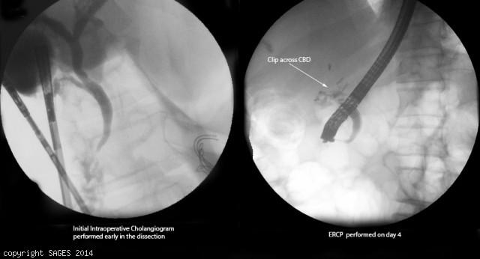
Concern for clip across CBD
- Antibiotics
- IR consultation for PTC.
You take the patient to the OR for repair, how do you repair the following?
- Injury < 50% circumference, not caused by cautery - Repair over T tube.
- Transection < 1 cm in size and away from bifurcation - End to end anastomosis.
- More severe injury, or close to the bifurcation: Hepaticojejunostomy -- Describe.
Scenario 3: Same patient however with AST/ALT and Alk phos within normal limits, Tbili slightly elevated to 2.4. RUQ US shows concern for large fluid collection in the RUQ.
1. HIDA: Shows biliary leak.
2. ERCP obtained → cystic duct stump leak confirmed → Sphincterotomy and Stent
3. IR for drainage of RUQ fluid collection if symptoms do not resolve, persistent leakage or septic.

Room 5 Question 3
Carotid Artery Stenosis (Reviewed by Dr. Yamaguchi)
Stem: You are called to evaluate a 60 Year-old male admitted to the medicine service earlier today after a brief period of weakness in the right arm and facial droop which have now fully resolved.
He has a medical history significant for poorly controlled diabetes, hypertension on HCTZ, no significant surgical history, and admits to a 50 pack-year smoking history.
He is afebrile with normal vital signs, and is now at his neurologic baseline, GCS 15 with full motor and sensory function throughout.
On physical exam, you auscultate bilateral subtle carotid bruits.
His admission labs are unremarkable aside from hyperglycemia. During his workup for stroke he received a non-contrast CT of the head which ruled out intracranial abnormalities, and a carotid duplex is ordered.

What is your Differential Diagnosis?
- Carotid artery stenosis causing TIA
- Embolic TIA from cardiac origin
- Carotid dissection
- Aneurysm
- Vasculitis

What would you like to do now?
- Results of duplex: Left carotid artery stenosis 90%, right 70%. Peak systolic velocities of 250 cm/s bilaterally.

Any other studies ?
- CT angiography (if there is concern for location)
- Digital subtraction angiography (gold standard), or MRA.
- EKG
- Echocardiogram… Why?
  - look for Afib, PFO, other structural heart defects

How would you like to treat the patient?
- Pre-operative medical optimization and risk stratification
- Begin intense medical therapy for carotid artery stenosis including counseling for smoking cessation, antiplatelet and high-dose statin therapy
- Offer Left Carotid Endarterectomy only. This is the symptomatic side, so it takes priority. The right side meets criteria for asymptomatic CEA but should be deferred.

Steps of the surgery

Conventional Method
- Incision alongside the medial aspect of the sternocleidomastoid muscle.
- Dissecting deeply to reach the carotid sheath.
- Ligate the common facial vein to expose the carotid arteries.
- The internal carotid artery is clamped proximal and distal to the plaque temporarily.
- Open along the length of the internal carotid artery, progressing proximally and distally to locate both ends of the plaque.
- The clamps are released one at a time and a flexible bypass shunt is placed
- Blockage is removed.
- The artery then repaired with a patch that will widen the vessel lumen, and the shunt is removed.
- Satisfactory blood flow is confirmed with ultrasound Doppler or angiography.
Eversion Method
- The internal carotid artery is transected at its origin at the bifurcation.
- The vessel wall is everted circumferentially around the plaque
- Plaque is divided and removed.
- The artery is then repaired in an end to end anastomotic fashion.

Scenario 2: Asymptomatic Carotid Stenosis

Different patient with carotid Stenosis found on screening doppler exam, what are indications for surgery?

Stenosis between 60-99%.

What would current intensive medical management of Carotid Stenosis entail?
    - Smoking cessation
    - Antiplatelet agent
    - Lipid lowering therapy
    - Hypertension management
    - Diabetes management)

Scenario 3: Your patient in the recovery room now with after CEA with new onset facial droop and dysarthria? What would you do?
- Return to the operating room, re-explore the vessels looking for an intimal flap
- Perform internal carotid thrombectomy

Also reasonable to obtain rapid bedside ultrasound evaluation if available

